NB!
Hochberg, M.E. and Noble, R.J. (2017), A framework for how environment contributes to cancer risk. Ecol Lett, 20: 117-134. https://doi.org/10.1111/ele.12726
Wells, K., Hamede, R.K., Kerlin, D.H., Storfer, A., Hohenlohe, P.A., Jones, M.E. and McCallum, H.I. (2017), Infection of the fittest: devil facial tumour disease has greatest effect on individuals with highest reproductive output. Ecol Lett, 20: 770-778. https://doi.org/10.1111/ele.12776
Hamede, R.K., Bashford, J., McCallum, H. and Jones, M. (2009), Contact networks in a wild Tasmanian devil (Sarcophilus harrisii) population: using social network analysis to reveal seasonal variability in social behaviour and its implications for transmission of devil facial tumour disease. Ecology Letters, 12: 1147-1157. https://doi.org/10.1111/j.1461-0248.2009.01370.x
Cunningham, C.X., Comte, S., McCallum, H., Hamilton, D.G., Hamede, R., Storfer, A., Hollings, T., Ruiz-Aravena, M., Kerlin, D.H., Brook, B.W., Hocking, G. and Jones, M.E. (2021), Quantifying 25 years of disease-caused declines in Tasmanian devil populations: host density drives spatial pathogen spread. Ecology Letters, 24: 958-969. https://doi.org/10.1111/ele.13703

Distinct ecologies of two lineages of blue mussel transmissible neoplasia parasitizing Mytilus trossulus Gould in Taui Bay (Sea of Okhotsk)
Distinct ecologies of two lineages of blue mussel transmissible neoplasia
Distinct ecological phenotypes of two lineages of blue mussel transmissible neoplasia (MtrBTN1, MtrBTN2): response to local environmental gradients and effect on the host (Mytilus trossulus).
Two lineages of blue mussel transmissible neoplasia (MtrBTN1, MtrBTN2) react differently to local environmental gradients and have different effects on their host (Mytilus trossulus).
Two species of blue mussel transmissible neoplasia respond differently to local environmental gradients and exert different effects on the reproduction and growth of their hosts.
Two species of blue mussel transmissible neoplasia respond differently to local environments and exert different effects on their hosts.
Abstract (150 words).
Transmissible cancers, the malignant cell lineages that metastasize between individuals through the transfer of living cancer cells, are compared to parasitic species. Within the framework of this hypothesis, different cancer lineages must manipulate their hosts and possess distinct ecological phenotypes. Here, we test these predictions using two lineages of Mytilus trossulus derived blue mussel transmissible neoplasia (MtrBTN1, MtrBTN2) parasitizing M. trossulus in the Sea of Okhotsk. Если больше слов то вот место объяснить что делали. The prevalence of MtrBTN1 correlated positively with wave exposure, distance from the port, lifetime growth rates and abundance of old mussels, while the prevalence of BTN2 varied insignificantly against all predictors but growth rate. Conclusions on higher eurybionticity of MtrBTN2 fits knowledge on its wider geographic distribution and range of host species. Both lineages reduced the host's fertility, but MtrBTN2 did so from earlier stages of the disease and, unlike MtrBTN1, stimulated mussel growth through last growth season. Thus, the two cancers have distinct ecologies and follow different parasitic strategies, with the MtrBTN2’s strategy resembling parasitic castration accompanied by a host’s gigantism.

Intro
Clonally transmissible cancer (CTC) is a neoplastic disease passed from individual to individual by transfer of living cancer cells (Murchison 2008). Thirteen such cancers are known, the Canine transmissible veneral tumour (CTVT) in domestic dogs (Murgia et al., 2006; Rebbeck et al., 2009), two independent lineages of Devil facial tumour disease (DFTD1, DFTD2) in Tasmanian devils Sarcophilus harrisii (Pearse & Swift, 2006, Pye et al., 2016), and 10 lineages of Bivalve transmittable neoplasia (BTN), including three cases when two lineages derived from the same species, in marine bivalves (Metzger et al. 2015, 2016; Garcia-Souto et al. 2022; Michnowska et al., 2022; Yonemitsu et al., 2019, 2025). CTVT and DFTDs are solid tumors and cancer cells are transmitted between animals through sexual contacts and biting, respectively. BTN is a hemolympharic cancer, or disseminated neoplasia (DN) (see references above). Under DN, the disease primarily affects the hemolymph but eventually infiltrates all tissues and organs (Carballal et al. 2015; Odintsova 2020). The cancerous cells - neoplastic hemocytes - are passed between molluscs through water column where cells survive for days and even weeks (Burioli et al., 2021; Giersch et al., 2022). In addition, vertically transmitted cancers are known in cnidarian Hydra oligactis when cancer cells are transmitted through the asexual reproduction of its host, by budding (Domazet-Lošo et al. 2014; Tissot et al. 2024).
Transmissible cancers are asexual but are prone to horizontal transfer of mtDNA from their hosts (Rebbeck et al. 2011; Yonemitsu et al. 2019; 2025; Bruzos et al. 2023), and even nuclear DNA, as have been shown in a recent CTVT study (Gori et al. 2025). The estimates of evolutionary age are available for CTVT, 4 to 8.5 thousand years (Baez-Ortega et al., 2019), DFTD1 and DFTD2, about 40 and 15 years respectively (Stammnitz et al. 2023), and BTN of soft shell clam Mya arenaria, several hundred years (Hart et al. 2023). Fatal outbreaks of CTC were recorded in molluscs (Weinandt et al. 2024; Skazina et al. 2023b – что церастодерма?) and in devils (Cunningham et al. 2021). The later may be explained by the young age of DFTD lineages, hence short history of host-pathogen coevolution (Storfer et al. 2025 and references therein).
СТС is a distinct modality of the infectious agent (Metzger, Goff 2016). Like any parasites, transmissible cancers are expected to manipulate their hosts i.e. to change the host’s phenotype in order to increase the parasite fitness (Tissot et al. 2016). Convincing evidence in support of this hypothesis has been obtained for vertically transmitted cancers in Hydra: the cancer triggers the growth of additional tentacles in their hosts, which provides the host with higher foraging efficiency and the cancer itself with increased proliferation (Boutry et al. 2025). One potential example of host’s manipulation by horizontally transmissible cancer will be given below.
It is obvious CTC lineages can be viewed as species (e.g. Vincent 2010; Ujvari et al. 2016), but their supposed ephemerality prevents most experts from recognizing them species as a matter of fact (e.g. Metzger, Goff 2016; Leathlobhair, Lenski 2022). Taking this controversial stance - that CTC lineages are species, and adopting the idea that different species should have different “ecological niches” (Van Valen 1976) - we arrive at a testable hypothesis: they must possess unique ecological phenotypes and exert differential effects on their hosts. The best models for studying ecological distinction of CTC lineages are that derived from the same parental species, in sympatry. Comparative ecological data on such lineages are scarce, which is due to their recent discovery in devils and bivalves. Based on indirect evidence—features of metabolism and proliferation in cell culture of DFTD1 and DFTD2, the second, more young, lineage is more aggressive (Gérard et al. 2024; Gérard et al. 2026). For BTN, the best-studied are the blue mussel Mytilus trossulus derived lineages, MtrBTN1 and MtrBTN2, which are the objects of the present study and therefore will be presented in more detail.
Что накопали про мию?
The age MtrBTN1 and MtrBTN2 is not known for certain. According to limited molecular data, their age appears to be similar and closer to the age of Mya BTN than to CTVT or DFTD’s (Yonemitsu et al. 2019; Buriloi et al. 2023). MtrBTN1 parasitizes its parental species, M. trossulus, and is distributed in the northern Pacific Ocean and European subarctic. MtrBTN2 parasitizes three other species of Mytilus in addition to M. trossulus and has a broad range in the temperate seas of the Atlantic and Pacific Oceans in both hemispheres. In Europe, its range extends from the Mediterranean Sea to the subarctic and covers the temperature ranges of three host species (Hammel et al. 2022; Skazina et al. 2023a; Skazina et al. 2023b). The geographically disjunct distributions of MtrBTN1 and MtrBTN2 are explained through anthropogenic introductions, together with diseased mussels in the fouling of ship hulls (Yonemitsu et al. 2019; Skazina et al. 2023b). To sum up, according to available data, the MtrBTN2 is more eurybiontic than MtrBTN1 both in respect to host genotypes and abiotic environment.
While nothing is known about MtrBTN1 beyond its geographic distribution, progress has been made in understanding the ecology of MtrBTN2 due to studies of Bouroli et al. 2021 and Hammel et al. 2024. Both studies were conducted on the Atlantic coast of France, where this M. trossulus-derived lineage parasitizes M. edulis and M. galloprovincialis and exhibits a low overall prevalence of about five cancerous mussels per thousand (Hammel et al. 2022). Hammel et al. (2024) studied the spatial ecological patterns of MtrBTN2 prevalence, taking into account mussel density and species identity, and a set of environmental predictors, including surf intensity and proximity to ports. They found similar cancer prevalence in both mussel species, and a higher prevalence in ports. The latter result can be explained both by ports serving as epidemiological hubs through the transport of affected mussels in the fouling of ships' hulls, and by the conditions within ports, including increased mussel density, reduced surf intensity and high levels of anthropogenic pollution (Hammel et al. 2024). Of note, the idea of increased DN prevalence in polluted habitats was considered in old studies predating the BTN discovery and assuming that carcinogens directly provoke the disease. No convincing evidence was obtained however (Barber 2004; Carballal et al. 2016).
Что recent review of Bramwell?
Using histological data on control healthy and 16 MtrBTN2-infected M. edulis sampled through different seasons, Burioli et al. (2021) demonstrated lack of ripe gametes in most cancerous mussels and suggested that MtrBTN2 inhibit hosts gametogenesis since early stages of disease. They hypothesize that MtrBTN2 follows a parasitic castration strategy, that is, a strategy that requires the eventual intensity-independent elimination of host reproduction as the primary means of acquiring energy for parasite (Lafferty, Kuris 2002). Given the limited material in Burioli et al. (2021) study, their inspiring hypothesis cannot be considered definitively proven. As the disease progresses, BTN colonizes all organs and tissues of the mussel, including the gonads (Carballal et al. 2016; Odintsova 2020), and inevitably negatively affects the mussel's health. It is unclear whether the castration in this case is an adaptive strategy of the parasite, rather than a secondary outcome of infection with no adaptive value.
MtrBTN1 and MtrBTN2 occur in sympatry in M. trossulus populations of Taui Bay (Sea of Okhotsk, NW Pacific subarctic), with a cumulative prevalence of about 5% (Skazina et al. 2023a). Here we use the co-infected Taui Bay mussel populations for a comparative ecological study of the two lineages. Our questions are as follows. What are the patterns of MtrBTN1 and MtrBTN2 prevalence between mussel populations with different demographics and from different habitats? How these lineages affect mussel's reproduction and growth? By conducting our research, we, firstly, continue the studies of MtrBTN2 initiated by Hammel et al. (2024) and Burioli et al. (2021) in Europe and verify their results in the other ocean on populations of another host species—specifically, the parental species for this cancer. Secondly, we study ecology of MtrBTN1 for the first time. Finally, we check the hypothesis of individuality of the two lineages. If MtrBTN1 and MtrBTN2 are indeed different parasitic species, then they should react differently to local environmental gradients and exert different effects on their hosts. Or perhaps theoretical expectations regarding the essence of transmissible cancers as species, as applied to MtrBTN, are exaggerated, and, being recently feral clones of the same cancer, the disseminated neoplasia, without long history of co-evolution with a host and competition with each other, they are indistinguishable ecologically?
Materials and Methods
Study sites. The mussels M. trossulus are numerous and nearly ubiquitous on the predominantly rocky littoral of Taui Bay, where their average biomass is measured in kilograms per m² (Fig 1C, Khalaman et al. 2020). In June 2021 we examined mussels from 11 sites, and in June 2023, from 13 sites over the bay, with six sites being studied in both years (Fig 1B). The sites, defined as a coastal stretch of about a hundred meters, were chosen according to transport accessibility and to capture variation in surf intensity, distance from rivers, and distance from the only city and port in the study area, Magadan. At each site, surface salinity was measured at low water by refractometer, and mussel projective cover was scored on a point scale: 1 – <10%, 2 – 10–25%, 3 – 25–50%, 4 – >50%. The cover was scored visually in situ in 2021, and from the digital analysis of 30 photos of different parts of the site taken from a height of 2.5 meters in 2023. For each site, the distance from the port along the coastline was calculated from the map as a proxy for anthropogenic impact, while fetch—the unobstructed length of water surface over which wind blows—was calculated using the same map and the R package 'waver' (Marchand & Gill 2018) as a proxy of surf intensity.
Mussel sampling. Mussels were collected separately for studies of BTN and of mussel demography. For demography, three quantitative samples were taken at random using a variable-area frame 0.0066-0.0815 m², where the area was adjusted according to mussel density. No samples for demography were collected from two sites (Kar23, On23 in Fig. 1B). For BTN, quantitative samples of mussels (sample size N=64-230) with a shell length exceeding 20 mm (a size allowing hemolymph collection) were collected from the entire area of the site. Total number of mussels studied for BTN was 1199 in 2021 and 1631 in 2023.
Processing of samples for demography. Samples were washed through a 1 mm mesh sieve. Shell length of all mussels was measured to the nearest 1 mm. Mussels were then divided into size classes at 5 mm intervals (0–5 mm, 5.1–10 mm, etc.). A total of 112 mussels of different sizes from multiple sites were individually weighed to the nearest 0.01 g, and the relationship between shell length and wet weight was calculated. Mussel populations at each site were characterized by density of different size classes, biomass predicted from mussel length, and by projective cover. Since all these variables are correlated, their variation was summarized using Principal Component Analysis (PCA), and the scores of the first two principal components (PC1, PC2) were treated as integral characteristics of mussel abundance and age structure in further analyses.
Processing of samples for BTN. Mussels were processed within few days after sampling. All or random part of the mussels from all samples except MCHK21, VES23 and ARM23 were sexed based on mature gametes in gonad smears under a light microscope in 2021 or an inverted microscope in 2023 at ??? magnification. From all mussels, pieces of foot muscle and aliquots of hemolymph (collected from the posterior adductor with the help of a syringe with a 22-gauge needle) were fixed in 70% ethanol for subsequent diagnosis of DN and BTN. Hemolymph quality was controlled by examining droplets of fresh hemolymph under the same microscopes. Neoplastic cells were often readily observable in such preparations (see Fig. 1D). In 2023, whole bodies of selected mussels suspected of having DN (N = ) and control presumably healthy mussels (N=) from multiple sites were fixed in 4% paraformaldehyde in PBS (pH 7.8) for histology. Shells from both sampling years were preserved for growth analysis.
Fig1. Study sites and study objects. A. North Pacific, the star marks Magadan. B. Taui Bay. The city of Magadan is shown in dark shading, and the port is marked with an anchor. The studied sites are indicated, with abbreviated site names and sampling years (21 – 2021, 23 – 2023). The sizes of the pie charts are proportional to the prevalence of BTN (see the legend) while sectors indicates the proportions of BTN COI genotypes (see the legend where sectors are proportional to overall frequencies). C. Typical mussel habitat at site ???; standing human height – 183 cm. D. Droplets of fresh hemolymph from a healthy mussel (left) and from the mussel infected with BTN (MtrBTN?, ??% of cancer cells in hemolymph by FC). Healthy hemocytes are relatively few in number, have a lobed shape, flatten out on the slide, whereas neoplastic cells are numerous, round, and lie freely.

DN and BTN diagnostics. DN was diagnosed by flow cytometry (FC) of hemolymph as in Vassilenko and Baldwin (2014) and Skazina et al. (2021). If aneuploid cells, a hallmark of DN, was present, their rate (a measure of the infestation level and, accordingly, the severity of the disease) and modal ploidy (ploidy vs. healthy hemocytes) were estimated. The latter was not possible for heavily diseased mussels with the rate of aneuploid cells close to 100% however. For BTN diagnosis, the mtDNA COI test originally developed on mussels from Taui Bay (Skazina et al. 2023a) was used. The test involves parallel mtDNA COI sequencing from foot muscle and hemolymph of mussels with DN, followed by visual interpretation of chromatograms. Both MtrBTN1 and MtrBTN2 have unique sets of COI alleles, which are visible on chromatograms of diseased mussels, usually against the background of the host genotype (as double peaks): in weakly infected individuals — in hemolymph, in strongly infected individuals — in both tissues. Following Vassilenko and Baldwin (2014), mussels with >5% aneuploid cells by FC were classified as DN-affected. However, because the COI test has a detection sensitivity of about 10-15% of aneuploid cells (Skazina et al. 2023a), BTN was tested only for mussels with no less than 10% such cells.
Analysis of mussel growth. For all BTN-infected mussels and for 10–18 healthy mussels from each site, the shell length was measured, and age and growth curves — shell length in different years of life — were reconstructed using marks of winter growth delays on the shells (“growth rings”) as in Sukhotin et al., 2007. Growth curves were approximated using the von Bertalanffy growth equation. Two growth characteristics were determined: an overall growth performance (OGP), which describes the lifetime growth rate (Brey, 2001), and the relative growth increment during the last growth season (GI) i.e., from the end of the ice-covered period in May until the date of mussel sampling. OGP= log(L∞∗K), where L∞ and K – parameters of the von Bertalanffy equation. GI = (Lt-Lr)/Lt, where Lt – total shell length, Lr - shell length at the last growth ring.

In addition to the OGP index calculated individually for each mussel, the OGPₛᵢₜₑ index was computed to characterize the overall growth performance of mussels at a given geographical location (Marchenko et al., 2026). For this purpose, growth data obtained from healthy specimens with 3 to 10 winter growth marks were used. For each site, mean shell length was calculated for each age class. Based on this data, the parameters of the von Bertalanffy growth equation were fitted parameter of which were used for OGPₛᵢₜₑ calculation.

Histological analysis. Histological sections stained with Meyer’s hematoxylin-eosin were processed as in Usheva and Frolova (2000) and examined using the light microscope ???? equipped with a digital camera. and SOME GRID. For each mussel, the areas of the cell and nucleus of 10 randomly selected healthy hemocytes and 30 neoplastic cells were measured using AxioVision LE software (Carl Zeiss, Germany), and the nuclear-to-cell ratios (NCR) were calculated.
In sections through the gonad (35 BTN infected and 14 healthy mussels), the relative proportion of germinal tissue was evaluated as the frequency of grid nodes (++х++ evenly distributed grids) falling on acini versus the frequency of nodes falling on connective tissue.
ased on at least ??? measurements. The proportion of nodes located within the acini was used as a relative measure of acini size to estimate individual reproductive performance.
Analysis of associations between MtrBTN1 and MtrBTN2 prevalence and environmental and demographic predictors.
We employed a binomial Generalized Mixed effect Additive Model (GAMM; Wood 2017) with a logit link function (Model 1, Table ++). To account for lineage-specific responses, separate smooth functions were fitted for each level of the factor “Lineage” (MtrBTN1 or MtrBTN2) for the following continuous predictors: salinity, distance from the port, fetch (since several fetch values exhibited substantial deviation from the remaining observations, logarithmic transformation of this predictor was applied), mean OGP_{site}, PC1 and PC2. Each smooth term was implemented using a cubic regression spline with a shrinkage basis to allow for potential nonlinear patterns. A parametric term for “Lineage” was also included to assess the differences in intercepts between MtrBTN1 and MtrBTN2. To control for unmeasured temporal and spatial variation, we included a smooth random effect, which treats the interaction of year and site as a random intercept. We did not include salinity as a predictor in the model, as its values showed virtually no variation across sites.The model was fitted using restricted maximum likelihood method. To assess the validity of the Model 1, we performed a residual diagnostic analysis using the DHARMa package (Hartig, 2022). No violations of model assumptions were detected.
Analysis of the effect of MtrBTN1 and MtrBTN2 on mussel reproductive performance
To evaluate the effect of BTN infestation level on mussel reproductive fitness (the latter quantified as relative acinar size), we fitted a binomial logistic regression model (Model 2, Table ++). Infestation level was determined by flow cytometry as the proportion of aneuploid cells in the hemolymph of infected mussels, and the model included BTN-lineage (discrete factor), aneuploid cell proportion (continuous predictor), and their interaction as independent variables. The 95% confidence interval for Model 2 was calculated using a bootstrap procedure. Separately, the mean relative acinar size for healthy mussels was estimated along with its 95% bootstrap confidence interval. These observed data were then visually compared with the predictions from Model 2.

Analysis of the effect of MtrBTN1 and MtrBTN2 on mussel growth
Model 3 (GAMM, Table ++) was fitted to evaluate the dependence of relative shell increment on BTN infection status. The analysis included both infected and uninfected mussels; however, only healthy individuals whose shell length fell within the range observed for infected specimens were retained. The response variable, defined as the ratio of the most recent annual increment to total shell size, was subjected to Fisher's ϕ‑transformation to improve normality. The model incorporated a fixed effect of BTN lineage (BTN_Type, a three‑level categorical factor: Healthy, BTN1, and BTN2). To account for the influence of shell size on incremental growth, the distance from the umbo to the last growth winter mark (Last_ring) was included as a covariate, along with individual OGP. The effects of these two covariates were modeled using nonparametric smoothing cubic splines, with the spline shape allowed to vary across BTN_Type levels. A random site effect was also included to account for inter‑site variation. Model parameters were estimated using REML. Post-hoc comparisons of partial effects for relative increment between BTN_Type levels were performed using Wald tests, implemented via the wald_gam() function from the itsadug package (van Rij et al., 2025).

Table +++. Model specifications and parameter definitions for the statistical analyses conducted.
Model name | Model type | Dependent variable | Predicors | Residual distribution type
Model1 | GAMM | Probability of detecting an infected individual | Lineage (two levels discrete: BTN1, BTN2)  s(PC1), s(PC2) - population structure proxies  s(OGP_{site}) - site specific group growth rate  s(Dist_Port) - distance to Magadan sea port  s(LogFetch) - shore opennes for wave impact  Interaction(Site, Year) - random effect of samplings | Binomial
Model2 | GLM | Probability of a grid node falling within an acinus. | Lineage - (two levels discrete: BTN1, BTN2)  Aneuploidy_rate - Proportion of aneuploid cells in hemolymph  Lineage:Aneuploidy_rate - interaction term | Binomial
Model3 | GAMM | ϕ-transformed Relative incremrnt | BTN_status - three levels discrete factor (Healthy, BTN1, BTN2)  s(Last_Ring) - distance from umbo to the last winter mark (proxy for mussel size)  s(OGP) - individual OGP index (proxy for mussel growth rate)  Ste - random effect of site | Gaussian
Note. s() - denotes GAM-smoother term. All smoothers were fitted for each lineages separately.

Res
Mussel demography. A detailed results including population size structures and PCA based on densities of size classes, biomass, and projective cover are provided in ESM 1. Mussel biomass ranged 3-22 kg/m² (average 12.5 kg/m²). The size structure varied from unimodal with absolute dominance of small mussels <10 mm to bimodal with dominance of both small and large mussels >30 mm. In the PCA, PC1 (34% of the total variance) was associated with age structure, while PC2 (17%) was associated with projective cover, biomass, and density of intermediate size mussels. Samples dominated by small mussels had high positive PC1 scores, whereas samples with many large mussels had high negative scores. In the five out of the six sites studied in both 2021 and 2023, PC1 scores increased, meaning that the mussels there became younger on average.
BTN diversity and prevalence.
Disseminated neoplasia (DN) was confirmed in 48 mussels from 1199 in 2021 and in 77 from 1631 in 2023. All had the aneuploid rate ≥10% and therefore were studied for BTN. Always, aneuploid cells formed single peaks on FC plots, i.e. had constant ploidy within mussels (range between mussels 3.2n – 6n?). BTN COI1 alleles were revealed in all mussels with DN but three (with rates of aneuploid cells of 10%, 15% and 87%): MtrBTN1 alleles in ?? cases, and MtrBTN2 in ?? cases (see Fig.1B for more information). In three mussels two different cancerous alleles were detected simultaneously, each time from different lineages, suggesting a co-infection (see ESM2 for example chromatograms). For further analyses, these mussels were classified as either MtrBTN1 (one case) or MtrBTN2-affected based on the dominant genotype (i.e., higher peaks on the chromatogram). MtrBTN1 had significantly lower mean ploidy than MtrBTN2: 4.?n (range … ) vs. 5.?n () (Kruskall-Wallis).
Mean prevalence of MtrBTN1 was 2.07% and of MtrBTN2, 2.04%. The cumulative prevalence of lineages in samples ranged from zero (in ARM_23, BAT_23, MAM_21) to 7.3% (ZHEM_23) and 10.4% (MAR_23) (Fig. 1B). No significant spatial correlation was detected between the prevalence’s of the lineages (Spearman's r = 0.27, p = 0.208, n = 24).
Associations between MtrBTN1 and MtrBTN2 prevalence, environmental and demographic predictors.
The relationships between the prevalence of MtrBTN1 and MtrBTN2 and the predictors (salinity at low water, distance from the port as a proxy for anthropogenic impact, PC1 and PC2 as integral characteristics of mussel demography, OGP as a proxy for lifetime growth rates, and fetch as a proxy for surf intensity) in row data are visualized in SFig. ?, and the parameters of the GAM Model 1, which evaluates these relationships, are provided in STable 2. According to the model, which accounted for 76.7% of the deviance (adjusted R² = 0.71) no significant difference in general prevalence of BTN1 and BTN2 was found. However relation of two lineages to predictors was significant in some cases and differ for two lineages. Statistically significant associations were found between MtrBTN2 and OGP_{Site} and between MtrBTN1 and all predictors except salinity and PC2 and OGP_{Site} , with the association with OGP was marginally significant. The prevalence of MtrBTN1 significantly increased with increasing distance from the port and surf intensity.The relationship between MtrBTN1 prevalence and PC1 was distinctly non‑linear. High prevalence was observed at both low negative PC1 values (associated with a high abundance of older mussels in the settlement) and high positive PC1 values (indicative of a high abundance of juveniles). At PC1 values near zero, where medium‑sized individuals dominated the settlement, MtrBTN1 prevalence reached its minimum. abundance of large mussels (negative values of PC1), and their lifetime growth rate while The prevalence of MtrBTN2 was positively associated with mussel group growth rate (OGP_{Site}) and did not depend on other parameters (Fig. 2; Stable ?).

Вот мой вариант этого куска
The relationships between the prevalence of MtrBTN1 and MtrBTN2 and the raw values of the predictors - distance from the port (a proxy for anthropogenic impact), PC1 and PC2 (integral characteristics of mussel demography), OGPSite (a proxy for site‑specific lifetime growth rate), and fetch (a proxy for surf intensity) - are visualized in SFig. ?. The parameters of Model 1, describing the partial effects of these predictors, are provided in Table ++. The model explained 76.7% of the deviance (adjusted R² = 0.71) and revealed no significant difference in overall prevalence between the two lineages (parametric part of Model 1; lineage-specific intercepts). However, the partial effects of the predictors were significant in some cases and differed between lineages. Specifically, MtrBTN1 prevalence increased significantly with increasing distance from the port and with surf intensity. Its relationship with PC1 was distinctly non-linear: prevalence was high at both low negative PC1 values (associated with a high abundance of older mussels) and high positive PC1 values (indicating a high abundance of juveniles), while dropping to a minimum near intermediate PC1 values, where medium-sized individuals prevailed. In contrast, MtrBTN2 prevalence was positively associated only with site-specific growth rate (OGP_{Site}), with no significant relationships detected for the other predictors (Fig. 2; Table ++).

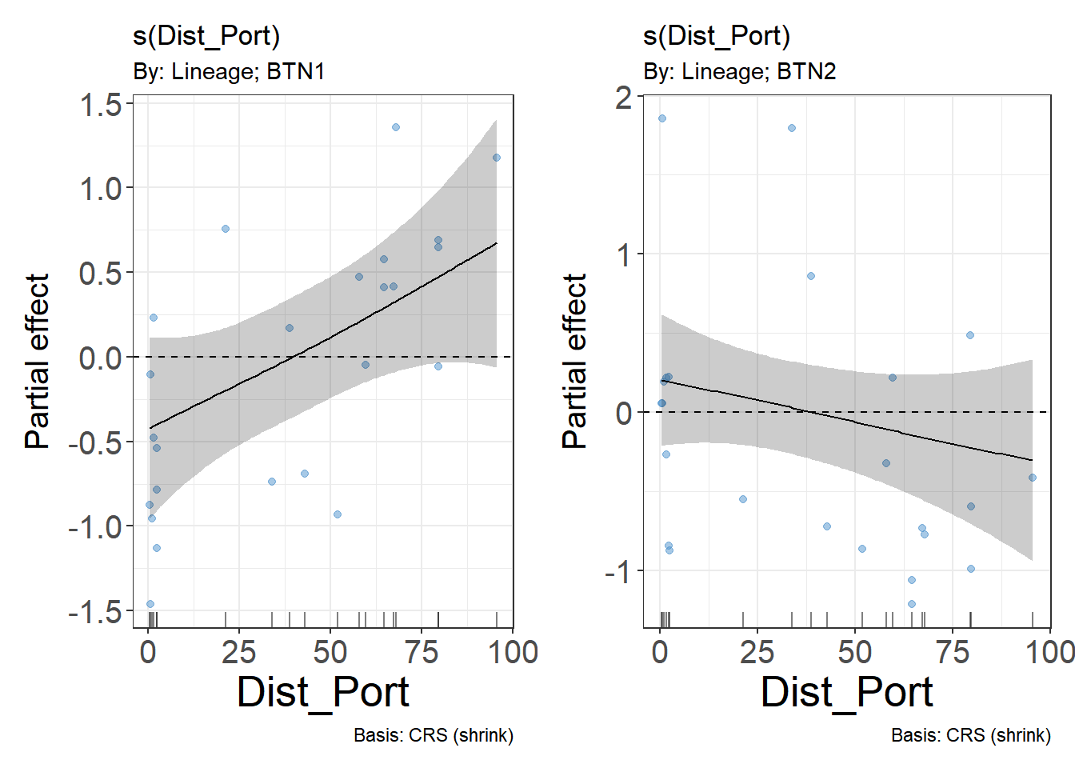
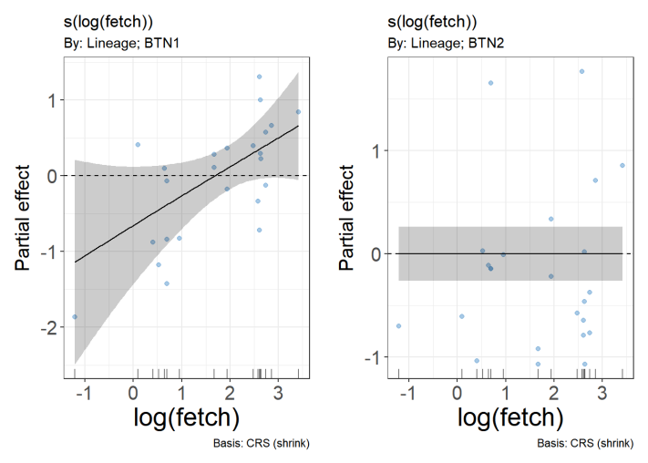
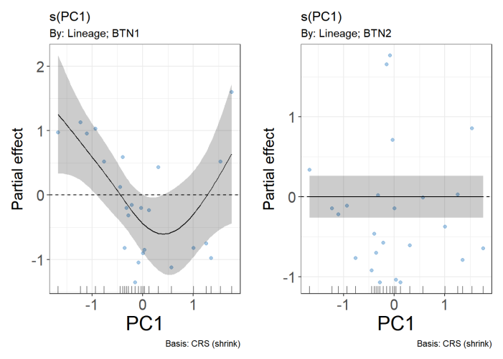
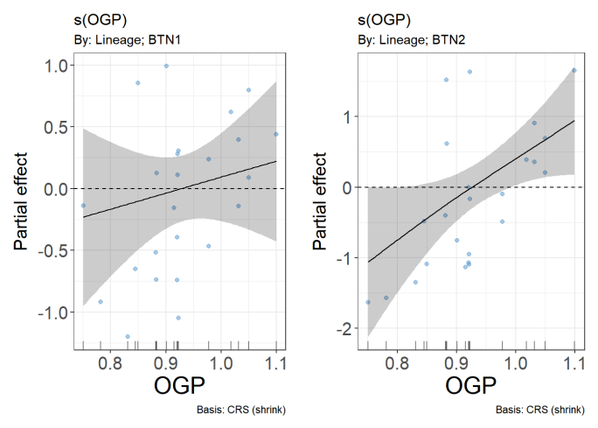
Fig. 2 Partial effects of environmental and demographic predictors on MtrBTN1 and MtrBTN2 prevalence evaluated by GAMM (Model 1). Dependency of prevalence on (A, B) distance to the port, the proxy for anthropogenic impact; (C, D) fetch, the proxy for surf intensity; (E, F) PC1, the proxy for mussel age structure; (G, H) OGP_{Site}, the proxy for mussel lifetime growth rate.

Table ++. Summary of the generalized additive mixed Model 1 assessing the effects of predictors on BTN prevalence. Parametric part of Model 1 was not significant (not provided).
Smoother term | edf | ref.df | F | p-value
s(Dist_Port):LineageBTN1 | 1.0 | 4.0 | 8.3 | 0.024 *
s(Dist_Port):LineageBTN2 | 0.7 | 4.0 | 3.0 | 0.217
s(log(fetch)):LineageBTN1 | 0.9 | 4.0 | 6.6 | 0.037 *
s(log(fetch)):LineageBTN2 | 0.0 | 4.0 | 0.0 | 0.838
s(PC1):LineageBTN1 | 2.2 | 4.0 | 29.5 | 0.004 **
s(PC1):LineageBTN2 | 0.0 | 4.0 | 0.0 | 0.979
s(PC2):LineageBTN1 | 0.0 | 4.0 | 0.0 | 0.953
s(PC2):LineageBTN2 | 1.8 | 4.0 | 9.4 | 0.764
s(OGP):LineageBTN1 | 0.4 | 4.0 | 0.7 | 0.222
s(OGP):LineageBTN2 | 1.0 | 4.0 | 14.8 | 0.007 **
s(Year,Site) | 9.8 | 23.0 | 20.7 | 0.003

Effect of MtrBTN1 and MtrBTN2 on mussel reproductive fitness

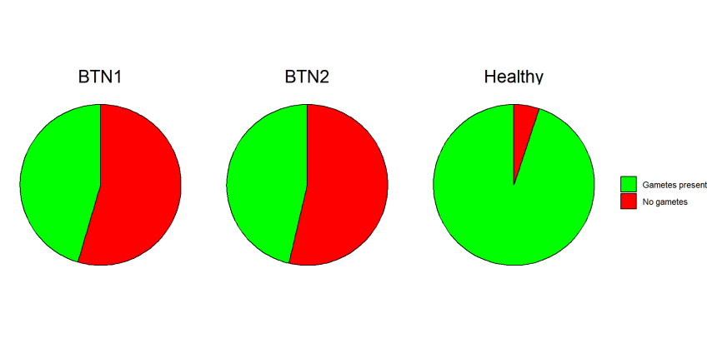
Figure. ++. Frequency of mussels with gametes in gonad smears and without gametes among mussels infected with different BTN lineages, compared to healthy specimens.
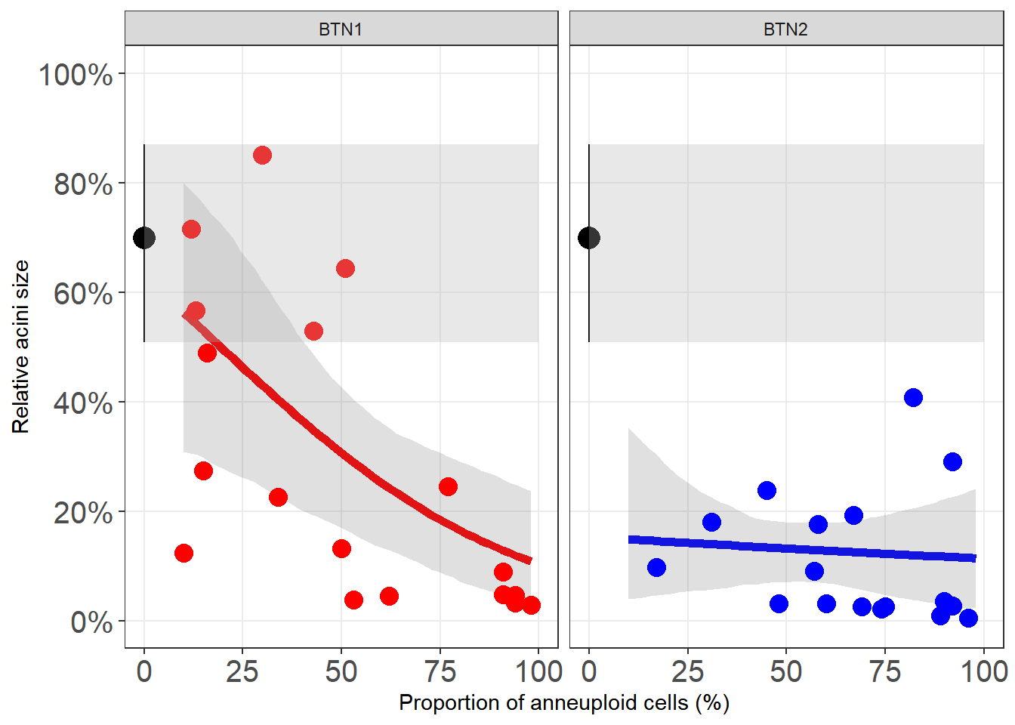
Figure +++. Relative acinar size (estimated as the probability of grid nodes overlapping germinal tissue) plotted against the proportion of aneuploid cells in the hemolymph (proxy for infection stage) for two BTN lineages. Solid lines denote predicted values from Model 3, and grey ribbons represent 95% bootstrap confidence intervals around the predictions. The black point with 95% bootstrap CI indicates the mean relative acinar size in healthy mussels.

Table ++. Summary for Model 2 describing association between relative acinin size and proportion of anneuploid cells in hemolymph.
Model term | estimate | std.error | Chi.sq Statistic | p.value
(Intercept) | 0.522 | 0.0262 | 19.9 | 0.0000
BTN_TypeBTN2 | -2.226 | 0.0566 | -39.3 | 0.0000
Aneuploidy_rate | -0.027 | 0.0005 | -50.0 | 0.0000
BTN_TypeBTN2:Aneuploidy_rate | 0.023 | 0.0009 | 25.8 | 0.0000

In gonadal smears from mussels diagnosed with BTN, gametes were absent in the majority of cases (Fig. ++), whereas they were found in the vast majority of healthy individuals. The relationship between relative acinar size (a measure of germinal tissue development) and the proportion of aneuploid cells in the hemolymph differed significantly between the two BTN lineages, as indicated by the significant interaction term in Table ++. In BTN2‑infected mussels, the extent of germinal tissue development remained consistently low from the earliest stages of infection and across the entire range of aneuploid cell proportions, staying below healthy levels. By contrast, a different pattern emerged for BTN1‑infected mussels: at low aneuploid cell proportions, relative acinar size was close to that of healthy individuals, but decreased progressively with disease progression.

Effect of MtrBTN1 and MtrBTN2 on growth of mussels

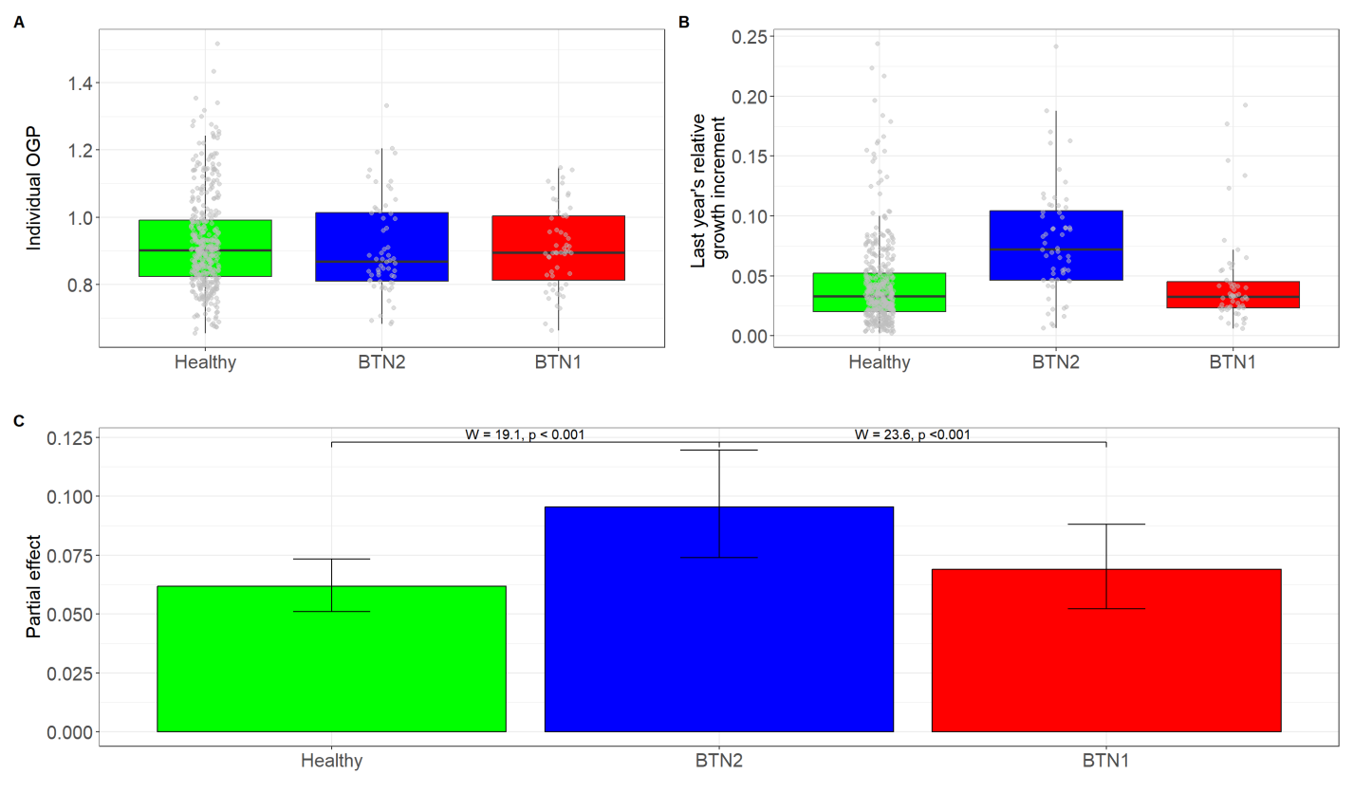
Figure ++. Growth of healthy mussels and individuals infected with BTN1 and BTN2. (A) Distribution of raw individual OGP values. (B) Distribution of raw last-year relative increment. (C) Model 3 predictions adjusted for the included covariates. Whiskers represent 95% confidence intervals; Wald test statistics are shown above the whiskers.

Table +++. Summary of Model 3 results for relative shell increment, including fixed effects of infection status (reference: Healthy), individual OGP, and shell size (Last_ring).
Parametric terms | estimate | std.error | F | p.value
(Intercept) | 22.74 | 1.05 | 21.64 | 0.0000
BTN_TypeBTN1 | -1.01 | 1.07 | -0.94 | 0.3483
BTN_TypeBTN2 | 4.89 | 1.01 | 4.86 | 0.0000

Smoother terms | edf | ref.df | F | p.value
s(OGP):BTN_TypeHealthy | 1.00 | 1.00 | 0.00 | 0.9532
s(OGP):BTN_TypeBTN1 | 3.25 | 4.01 | 1.55 | 0.1857
s(OGP):BTN_TypeBTN2 | 1.00 | 1.00 | 0.63 | 0.4264
s(Last_ring):BTN_TypeHealthy | 3.30 | 4.16 | 33.90 | 0.0000
s(Last_ring):BTN_TypeBTN1 | 2.28 | 2.87 | 8.98 | 0.0000
s(Last_ring):BTN_TypeBTN2 | 4.82 | 5.87 | 9.90 | 0.0000
s(Site_code) | 17.43 | 19.00 | 7.22 | 0.0000

Individual OGP values were similar between healthy mussels and BTN‑infected individuals (Fig. ++, A). By contrast, analysis of the raw values of the current year's relative increment revealed higher values in BTN2‑infected mussels compared to both BTN1‑infected and healthy individuals. Model 3 (Fig. ++, C; Table ++) further revealed statistically significant differences in increment between BTN2‑infected mussels and both healthy and BTN1‑infected individuals, whereas no significant difference (Wald-test = 0.88, p = 0.348 ) was detected between the latter two groups.

Discussion

Разнообразие и частота BTN в Тауйской губе
Наше исследование показало, что в Тауйской губе частота встречаемости обеих линий MtrBTN на порядок (а на некоторых сайтах на два порядка) превосходит значения, отмеченные в предыдущих исследованиях MtrBTN в поселениях мидий (+++Refs). Вместе с тем, мы допускаем, что частота MtrBTN в других исследованиях сильно недооценена. В старых исследованиях, посвященных изучению DN, было показано, что частота заболевания может достигать десятков процентов (Refs ). Поскольку в наших исследованиях и в работах +++Refs, в большинстве случаев присутствия у мидий DN было подтверждено наличие MtrBTN, мы можем предположить, что присутствие DN является надежным маркером заражения MtrBTN. Мы полагаем, что в благоприятных условиях могут возникать периодические всплески частоты заражения MtrBTN, которые, учитывая негитвное влияние на репродуктивную систему хозяина (Refs, и наши данные см. Ниже), оказывают существенное влияние на популяцию хозяина.

Сосуществование обеих линий MtrBTN в изученных нами поселениях также уникально, в предыдущих работах таких смешанных поселений двух линий MtrBTN отмечено не было. При этом мы обнаружили несколько случаев совместного присутствия клеток двух линий в тканях одного хозяина. Это говорит о том, что изученные нами биотопы крайне благоприятны для MtrBTN. Учитывая, что M.trossulus были родоначальниками обеих линий MtrBTN, можно предположить, что наблюдаемое широкое распространение двух линий MtrBTN в обследованном районе объясняется тем, что исследованные нами акватории находятся в пределах нативного ареала MtrBTN. Остальные описанные местообитания в Атлантике (+++Refs) и Средиземноморье (+++Refs) являются вторичными, связанными с заносом инфекционного начала в менее благоприятные местообитания, где представлены неспецифические хозяева (M.edulis, M.galloprovincialis).
То, что мы знаем о CTC и MtrBTN, в частности, позволяет рассматривать эти необычные формы жизни, как самостоятельные паразитические организмы. Это позволяет привлечь традиционную для экологии логику сравнительного анализа экологических фенотипов видов, то есть охарактеризовать их экологические ниши.
Пространство экологических осей для паразитических организмов подразделяется на две части: the host itself (immediate environment), nested in the surrounding environment (i.e. parameters of host ecosystem and host population density and demography) (Thomas et al., 2002; Van den Wyngaert et al. 2014).
Сосуществование двух видов паразитов в условиях симпатрии подразумевает, что экологические лицензии (термин +++ Ref), предоставляемые immediate environment и surrounding environment оказываются для них сопоставимыми. В этих условиях расхождения в реакциях на воздействия факторов должны трактоваться как признаки расхождения экологических ниш видов. Наше сравнительное исследование дает возможность описать расхождение ниш двух линий MtrBTN. К числу факторов immediate environment мы относим ресурсы самих хозяев в первую очередь энергетические ресурсы, обеспечивающие успешную пролиферацию клеток MtrBTN. К числу факторов surrounding environment мы относим характеристики биотопов, в которых обитают хозяева, а также параметры благостояния самих мидий (демографическая структура поселений, характеристики роста моллюсков).

Морфологические различия линий MtrBTN
Если бы мы имели дело с обычными видами паразитов, то различия в морфологии можно было бы трактовать, как признак расхождения ниш. Морфологических данных (размер клеток, ядерно-цитоплазматическое отношение?) у нас совсем нет?

Две линии MtrBTN демонстрируют разные связи с факторами surrounding environment
Мы изучили влияние пяти групп экологических факторов среды второго порядка, которые демонстрируют заметную изменчивость в изученном районе: расстояние от потенциального антропогенного стрессора (морской порт Магадана), степень волнового влияния (fetch), возрастная структура поселения мидий (PC1), биомасса и покрытие мидий (PC2) а также характеристики группового роста (OGP_{Site}). Model 1 показала, что MtrBTN1 и MtrBTN2 имеют статстически значимые связи с разным набором предикторов. Это говорит о том, что связь с параметрами surrounding environment для двух линий разная и мы можем говорить о расхождении экологических ниш двух линий MtrBTN.

Полученные результаты свидетельствуют о том, что частота MtrBTN1 в большей степени подвержена влиянию фильтров среды surrounding environment (об этом говорит количество значимых предикторов, три из пяти). Возможно, большее количество связей с параметрами surrounding environment может быть связано с большей чувствительностью клеток MtrBTN1 к условиям окружающей среды во время их свободного перемещения в толще воды. MtrBTN2 демонстрирует большую независимость от исследованных средовых градиентов, что может указывать либо на эврибионтность этой линии, либо на ведущую роль взаимодействий с immediate environment.

Неожиданным оказалось отсутствие значимых связей двух линий MtrBTN c PC2, которая несет информацию об общем обилии моллюсков на участке (биомасса, проективное покрытие). Таким образом, ожидаемая для эпидемиологических систем связь с обилием популяций хозяина (Refs+++) выявлена не была.
Для линии MtrBTN2 единственным значимым предиктором, из пяти изученных, была характеристика группового роста мидий (OGP_{Site}). Случаи заражения этой линией были чаще на тех сайтах, где мидии растут быстрее. Высокий темп роста моллюсков наблюдается в более благоприятных для мидий условиях (Refs+++). Известно, что высокая частота DN отмечена в тех регионах, где активно культивируют мидий, например на Тихоокеанском побережье США (Krishnakumar et al., 1999), в Чили (Campalan et al., 1998), в Канаде (Vassilenko, Baldwin, 2014) и во Франции (Hammel et al., 2023). Бизнес по выращиванию мидий процветает в наиболее благоприятных для мидий условиях, связанных с максимальной продукцией, а стало быть и ростом моллюсков. Возможные причины слабой зависимости частоты MtrBTN2 от средовых факторв мы обсудим ниже.

Вторая линия, MtrBTN1, имеет высокую встречаемость на удалении от ожидаемого источника антропогенного стресса (порт Магадана). Этот результат противоречит априори ожидаемому высокому распространению онкологических заболеваний в условиях антропогенного стресса (+++Refs). Возможно эта линия MtrBTN избегает стерссовых условий и процветает в условиях благоприятных для хозяина. В пользу этого говорит и положительная связь MtrBTN1 с открытостью для волнового воздействия. Прибойные условия обеспечивают приток пищи для мидий и приводят к снижению уровня седиментации (+++Refs), что делает прибойные местообитания более благоприятными для существования хозяина. Возможно и иное объяснение этой связи. Higher surf intensity may facilitate horizontal transmission of MtrBTN1 cells, since the disease is known to be potentially transmissible via waterborne cancer cells (+++Refs).
Третий фактор, регулирующий частоту MtrBTN1, оказался связан с демографической структурой поселения хозяев. Более высокую частоту заражения в поселениях, где доминируют старые особи, можно объяснить известной для паразитов особенностью аккумуляции инвазивных стадий в более долгоживущих старых особях (+++Refs). Однако можно предложить и другое, не противоречащее, объяснение. The U-shaped relationship between MtrBTN1 prevalence and PC1 - high in both juvenile-dominated (positive PC1) and old-dominated (negative PC1) settlements, low in intermediate-size populations - is a non-trivial finding. Известно, что поселения мидий - динамичные системы, демонстрирующие долговременные циклы, в которых наблюдается закономерная смена демографической структуры (Khaitov, Lentsman, 20++; Khalaman 20++).
Суть циклической модели популяционной динамики мидий сводится к следующему. Поселения, в которых доминирует молодь, по мере взросления моллюсков, перестают пополняться молодью вследствие конкурнеции между возрастными когортами (+++Refs). В лишенных притока молоди поселениях начинают доминировать особи среднего возраста. В последствии, в поселении начинают доминировать старые моллюски. После гибели значительной части старых особей пресс конкуренции между возрастным когортами снижается, и поселение вновь пополняется молодью (в таких поселениях часто наблюдается бимодальная размерная структура). После отмирания старой когорты в поселениии начиается массовый приток молоди. Цикл замыкается.
Таким образом, стадия с доминированием старых особей и стадия с доминированием молоди соседствуют в циклической схеме. На пяти сайтах из шести, описыванных как в 2021, так и в 2023 гг, мы отметили описанный выше переход от доминирования старых особей к доминированию молоди (SEM1). U-образная зависимость частоты MtrBTN1 от PC1 в такой ситуации получает объяснение. Можно предположить, что MtrBTN1 более адаптированы к заражению старых особей, например, ослабленных внутривидовой конкуренцией. Мидии среднего возраста, возможно, менее подвержены инвазии MtrBTN1 из-за наличия у них некоторых механизмов подавления или замедления пролиферации клеток этой линии. Всплеск частоты MtrBTN1, таким образом, приходится на завершающую стадию демографического цикла. Высокая частота MtrBTN1 в поселениях, с высоким обилием молоди объясняется тем, что в таких поселениях все еще присутствуют старые моллюски, доминировавшие на предыдущей стадии.
Если описанная гипотеза верна, то можно прогнозировать, что частота MtrBTN1 в поселениях мидий должна демонстрировать долговременные циклические колебания с периодом равным периоду изменений демографической структуры. Всплеск частоты заражения должен приходиться на переиод, когда в поселении доминируют старые особи. Для проверки этой гипотезы нужны долговременные мониторинговые наблюдения.

Две линии MtrBTN демонстрируют разные связи с факторами immediate environment
Организм хозяина, как биотоп, воздействует на организм паразита как положительно, предоставляя ресурсы, так и отрицательно, через иммунную систему (+++Refs). О механизмах борьбы мидий с MtrBTN известно мало, показано, что в ряде случаев возможна ремиссия заболевания (+++Refs). Наши наблюдения не позволяют оценить вклад отрицательных факторов immediate environment. Вместе с тем, наши наблюдения показывают, что между клетками MtrBTN и организмом хозяина возможно существуют тонко настроенные отношения, характерные для отношений между паразитами и хозяевами.
В предыдущих исследованиях было показано, что моллюски зараженные MtrBTN2 (а там точно были именно MtrBTN2?) часто демонстрируют нарушения гаметогенеза (+++Refs). Это влияние хорошо вписывается в представление об общей стратегии, характерной для многих паразитов, свзянной с паразитарной кастрацией (+++Refs), которая уменьшает траты хозяина на репродукцию, что позволяет паразиту получать дополнительную энергию.
В случае с многоклеточными паразитами такая стратегия очевидно приносит выгоду. Однако в случае с MtrBTN положительное влияние паразитарной кастрации не столь очевидно. Во-первых, нарушение развития гонад может быть не направленной кастрацией, а результатом общего нарушения функционирования организма хозяина, связанного с заражением MtrBTN. Во-вторых, вымет гамет у мидий сопряжен с разрывом тканей мантии, что могло бы быть удобными «воротами» для выхода клеток MtrBTN. В этой ситуации кастрация может затруднять выход клеток MtrBTN в воду стало быть может быть даже вредной.
Наше исследование подтвердило, что не только MtrBTN2, но и MtrBTN1 оказывает аналогичное воздействие на гаметогенез. Большинство больных мидий не производят гамет. Однако, на нашем материале было показно что характер воздействия двух линий MtrBTN на гонады хозяина сильно различается. Мы отметили, что MtrBTN2 уже на самых ранних этапах заболевания подавляет развитие гонад, относительный размер ацинусов у зараженных мидий много меньше, чем у здоровых особей, даже при очень небольшой пропорции аннеуплоидных клеток в гемолимфе (Fig. ++). В случае же MtrBTN1 на первых этапах развития болезни, когда доля анеуплоидных клеток еще не велика, степень развитости герминативной ткани сопоставима с таковой у здоровых моллюсков. Значительное снижение относительного размера ацинусов происходит уже на самых поздних стадиях развития заболевания (Fig. ++).
У трематод, для которых показана адаптивная роль паразитарной кастрации, как механизма увеличения притока энергии, кастрация промежуточного хозяина (моллюска) проявляется на самых ранних этапах развития партеногенетических поколений - уже на стадии спороцисты или при первых поколениях редий (+++Refs). Таким образом, если рассматривать нарушение развития гонад, как «целенаправленную» кастрацию, то такая стратегия, скорее, проявляется на ранних этапах развития инвазии. Постепенное подавление развития гонад по мере развития заболевания, должно, скорее, свидетельствовать о накопительном, хроническом эффекте, как результате общего ослабления организма хозяина вследствие паразитарной гагрузки. Если эта логика верна, то паразитарная кастрация, как хронический эффект, проявляется в скорее случае с MtrBTN1, чем с MtrBTN2.
Паразитарная кастрация, как адаптация, направленная на увеличение притока энергии от хозяина к паразиту, как правило, сопровождается перераспределением энергетических ресурсов хозяина от репродукции к соматическим процессам (+++Refs). Одним из возможных морфологических проявлений этого перераспределения может служить паразитарный гигантизм — увеличение размеров тела кастрированного хозяина по сравнению с незараженными особями. Иными словами, такое воздействие должно изменять рост хозяина.

Полученные нами данные можно трактовать в рамках этой концепции. Исследованные нами мидии не демонстрировали явных связей OGP с инвазией MtrBTN (Fig. +++). То есть параметры роста моллюска в течение всей его жизни не показывали связи с заражением. The absence of differences in OGP (a long-term cumulative metric) suggests that the effect is acute and recent, not a chronic trait.
Краткосрочный же рост, от последней зимней остановки, до момента отлова моллюска, продемонстрировал отчетливую связь с заражением MtrBTN2. Моллюски, зараженные этой линией выросли сильнее, чем здоровые особи и мидии, зараженные MtrBTN1.
Обобщая данные по развитию ацинусов и по характеру роста мидий, линия MtrBTN2, больше подходит на роль «манипулятора», регулирующего релокацию энергии через кастрацию хозяина. The "all-or-nothing" pattern (low acinar size even at minimal aneuploidy) suggests rapid and early colonization of the gonad, possibly because MtrBTN2 has a strong tropism for germinal tissue or triggers an aggressive host response that destroys gametogenic tissue before aneuploidy reaches high levels. Весте с тем, нельзя сбрасывать со счетов и то, что slow-growing MtrBTN2-infected mussels may die earlier, leaving only the fast-growing individuals in the infected sample (a "survivorship bias")
Линия MtrBTN1, вероятно осуществляет кастрацию как кумулятивный эффект, связанный с общим истощением хозяина. Такое воздействие не приводит к релокации энергии. The progressive decline implies a slower, dose-dependent pathology, where the host reproductive tissue is gradually replaced or impaired as the cancer load increases.

Фантазия. То, что MtrBTN1 на ранних этапах развития заболевания не тормозит репродукцию мидий это может способствовать отбору в сторону большей резистентности мидий против MtrBTN1.

Стратегии двух линий MtrBTN и географический паттерн распрделения
Our findings suggest that MtrBTN1 and MtrBTN2 represent biologically distinct disease entities, with different virulence strategies. MtrBTN2 можно рассматривать, как линию адаптированную к тонкому взаимодействию с организмом хозяина. Находясь под его защитой, эта линия MtrBTN может меньше зависеть от факторов внешеней среды второго порядка, быть более эврибионтной. Это в свою очередь возможно и позволяет клетками этой линии демонстрировать почти всесветное распространение и использовать в качестве хозяев по меньшей мере четыре вида рода Mytilus. Менее адаптированный к тонкому взаимоедйствию с хозяином MtrBTN1, возможно, является более уязвимой формой, лишенной «положительного» влияния со стороны хозяина. Возможно эта линия более агрессивна и патогенна. Если это так, то высокая частота такого паразита может достигать детектируемых значений только в условиях крайне благоприятных для хозяина, у которых он может жить дольше на фоне развивающегося заболевания, которое в менее благоприятных условиях привело бы к быстрой гибели зараженной мидии. Более стенобионтная линия MtrBTN1, видимо имеет очень узкие пределы толерантности к факторам surrounding environment, что делает ее ареал очень узким.

Conclusion
Our results show that MtrBTN1 and MtrBTN2, although co-occurring and equally prevalent, are ecologically and pathologically distinct. They differ in their: (1) environmental/demographic drivers; (2) effect on host reproduction; (3) effect on host growth (none vs. stimulation). This suggests that "MtrBTN" is not a single disease differing genetically but a syndrome of related transmissible neoplasias, each with its own niche and virulence strategy.

“Cancer as species”
…They even stretch our understanding of species, as the living lineage of cells that form CTVT has not been a dog in 10,000 years. It is unlikely that cancer lineages can be considered to be new species, but regardless of terminology, their evolution and replication strategies are clearly distinct from those of their hosts. These contagious cancer lineages have developed a new infectious lifestyle separate from that of the organism from which they arose, and their new interactions provide strong selective pressures, which can affect evolution of both host and pathogen. (Metzer, Goff))
MatMet
Не забыть упомянуть, что там очень много мидий
Diss
Из Hammel et al 24: the dilution of cancer cells in the marine environment may strongly limit the success of transmission over long distances

Murchison, E. Clonally transmissible cancers in dogs and Tasmanian devils. Oncogene 27 (Suppl 2), S19–S30 (2008). https://doi.org/10.1038/onc.2009.350
Metzger MJ, Goff SP (2016) A Sixth Modality of Infectious Disease: Contagious Cancer from Devils to Clams and Beyond. PLoS Pathog 12(10): e1005904. https://doi.org/10.1371/journal.ppat.1005904
Metzger, M., Villalba, A., Carballal, M. et al. Widespread transmission of independent cancer lineages within multiple bivalve species. Nature 534, 705–709 (2016). https://doi.org/10.1038/nature18599
Yonemitsu, M.A., Sevigny, J.K., Vandepas, L.E., Dimond, J.L., Giersch, R.M., Gurney-Smith, H.J., Abbott, C.L., Supernault, J., Withler, R., Smith, P.D., Weinandt, S.A., Garrett, F.E.S., Child, Z.J., Sigo, R.L.W., Unsell, E., Crim, R.N. and Metzger, M.J. (2025), Multiple Lineages of Transmissible Neoplasia in the Basket Cockle (C. nuttallii) With Repeated Horizontal Transfer of Mitochondrial DNA. Mol Ecol, 34: e17682. https://doi.org/10.1111/mec.17682
Tissot T, Arnal A, Jacqueline C, Poulin R, Lefèvre T, Mery F, Renaud F, Roche B, Massol F, Salzet M, Ewald P, Tasiemski A, Ujvari B, Thomas F. Host manipulation by cancer cells: Expectations, facts, and therapeutic implications. Bioessays. 2016 Mar;38(3):276-85. doi: 10.1002/bies.201500163.
Stammnitz MR, Gori K, Kwon YM, Harry E, Martin FJ, Billis K, Cheng Y, Baez-Ortega A, Chow W, Comte S, Eggertsson H, Fox S, Hamede R, Jones M, Lazenby B, Peck S, Pye R, Quail MA, Swift K, Wang J, Wood J, Howe K, Stratton MR, Ning Z, Murchison EP. The evolution of two transmissible cancers in Tasmanian devils. Science. 2023 Apr 21;380(6642):283-293. doi: 10.1126/science.abq6453
Vincent, M.D. (2010), The animal within: carcinogenesis and the clonal evolution of cancer cells are speciation events sensu stricto. Evolution, 64: 1173-1183. https://doi.org/10.1111/j.1558-5646.2009.00942.x
Garcia-Souto D, Bruzos AL, Diaz S, Rocha S, Pequeño-Valtierra A, Roman-Lewis CF, Alonso J, Rodriguez R, Costas D, Rodriguez-Castro J, Villanueva A, Silva L, Valencia JM, Annona G, Tarallo A, Ricardo F, Bratoš Cetinić A, Posada D, Pasantes JJ, Tubio JM. Mitochondrial genome sequencing of marine leukaemias reveals cancer contagion between clam species in the Seas of Southern Europe. Elife. 2022 Jan 18;11:e66946. doi: 10.7554/eLife.66946.
Carballal, M. J., Barber, B. J., Iglesias, D. & Villalba, A. Neoplastic diseases of marine bivalves. J. Invertebr. Pathol. https://doi.org/10.1016/j.jip.2015.06.004 (2015).
Barber BJ. Neoplastic diseases of commercially important marine bivalves. Aquatic Living Resources. 2004;17(4):449-466. doi:10.1051/alr:2004052
Giersch, R. M., Hart, S. F. M., Reddy, S. G., Yonemitsu, M. A., Orellana Rosales, M. J., Korn, M., Geleta, B. M., Countway, P. D., Fernández Robledo, J. A., & Metzger, M. J. (2022). Survival and detection of bivalve transmissible neoplasia from the soft-shell clam Mya arenaria (MarBTN) in seawater. Pathogens, 11(3), 283. https://doi.org/10.3390/pathogens11030283
Lafferty, K.D. and Kuris, A.M. (2002) Trophic strategies, animal diversity and body size. Trends Ecol. Evol. 17, 507–513
Domazet-Lošo T, Klimovich A, Anokhin B, Anton-Erxleben F, Hamm MJ, Lange C, Bosch TCG. 2014. Naturally occurring tumours in the basal metazoan hydra. Nat. Commun. 5 , 4222. ( 10.1038/ncomms5222)
Tissot S, Meliani J, Boutry J, Brazier L, Tökölyi J, Roche B, Ujvari B, Nedelcu AM, Thomas F, Dujon AM. De novo evolution of transmissible tumours in hydra. Proc Biol Sci. 2024 Sep;291(2031):20241636. doi: 10.1098/rspb.2024.1636.
Rebbeck CA, Leroi AM, Burt A. Mitochondrial capture by a transmissible cancer. Science. 2011 Jan 21;331(6015):303. doi: 10.1126/science.1197696. PMID: 21252340.
Bruzos, A.L., Santamarina, M., García-Souto, D. et al. Somatic evolution of marine transmissible leukemias in the common cockle, Cerastoderma edule. Nat Cancer 4, 1575–1591 (2023). https://doi.org/10.1038/s43018-023-00641-9
Boutry J, Rieu O, Guimard L, Meliani J, Nedelcu AM, Tissot S, Stepanskyy N, Ujvari B, Hamede R, Dujon AM, Tökölyi J, Thomas F. First evidence for the evolution of host manipulation by tumors during the long-term vertical transmission of tumor cells in Hydra oligactis. Elife. 2025 Mar 4;13:RP97271. doi: 10.7554/eLife.97271. PMID: 40036153; PMCID: PMC11879105.
Ujvari B, Gatenby RA, Thomas F. The evolutionary ecology of transmissible cancers. Infect Genet Evol. 2016 Apr;39:293-303. doi: 10.1016/j.meegid.2016.02.005. Epub 2016 Feb 6. PMID: 26861618.
Storfer A, Beer MA, Gallinson D, Jones ME, Hamede R, McCallum H, et al. (2025) The devil in more detail: Eco-evolutionary genomics of Tasmanian devil persistence despite range-wide spread of a fatal, transmissible cancer. PLoS Pathog 21(9): e1013523. https://doi.org/10.1371/journal.ppat.1013523
Cunningham CX, Comte S, McCallum H, Hamilton DG, Hamede R, Storfer A, Hollings T, Ruiz-Aravena M, Kerlin DH, Brook BW, Hocking G, Jones ME. Quantifying 25 years of disease-caused declines in Tasmanian devil populations: host density drives spatial pathogen spread. Ecol Lett. 2021 May;24(5):958-969. doi: 10.1111/ele.13703.
Ní Leathlobhair, M., Lenski, R.E. Population genetics of clonally transmissible cancers. Nat Ecol Evol 6, 1077–1089 (2022). https://doi.org/10.1038/s41559-022-01790-3
Carballal MJ, Iglesias D, Santamarina J, Ferro-Soto B, Villalba A. Parasites and pathologic conditions of the cockle Cerastoderma edule populations of the coast of Galicia (NW Spain). J Invertebr Pathol. 2001 Aug;78(2):87-97. doi: 10.1006/jipa.2001.5049.
Van Valen, L. (1976), ECOLOGICAL SPECIES, MULTISPECIES, AND OAKS. TAXON, 25: 233-239. https://doi.org/10.2307/1219444
Gérard, A.-L., Owen, R. S., Dujon, A. M., Roche, B., Hamede, R., Thomas, F., Ujvari, B., & Siddle, H. V. (2024). In vitro competition between two transmissible cancers and potential implications for their host, the Tasmanian devil. Evolutionary Applications, 17, e13670. https://doi.org/10.1111/eva.13670
Gérard AL, Pirard F, Vanbeek C, Dujon AM, Schultz AG, Hamede RK, Siddle HV, Thomas F, McKenzie M, Ziemann MD, Ujvari B. Metabolic pathways fuelling devil facial tumour diseases. FEBS J. 2026 Jan 29. doi: 10.1111/febs.70420
Gori K, Baez-Ortega A, Strakova A, Stammnitz MR, Wang J, Chan J, Hughes K, Belkhir S, Hammel M, Moralli D, Bancroft J, Drydale E, Allum KM, Brignone MV, Corrigan AM, de Castro KF, Donelan EM, Faramade IA, Hayes A, Ignatenko N, Karmacharya R, Koenig D, Lanza-Perea M, Lopez Quintana AM, Meyer M, Neunzig W, Pedraza-Ordoñez F, Phuentshok Y, Phuntsho K, Ramirez-Ante JC, Reece JF, Schmeling SK, Singh S, Tapia Martinez LJ, Taulescu M, Thapa S, Thapa S, van der Wel MG, Wehrle-Martinez AS, Stratton MR, Murchison EP. Horizontal transfer of nuclear DNA in transmissible cancer. Proc Natl Acad Sci U S A. 2025 May 6;122(18):e2424634122. doi: 10.1073/pnas.2424634122
Hart SFM, Yonemitsu MA, Giersch RM, Garrett FES, Beal BF, Arriagada G, Davis BW, Ostrander EA, Goff SP, Metzger MJ. Centuries of genome instability and evolution in soft-shell clam, Mya arenaria, bivalve transmissible neoplasia. Nat Cancer. 2023 Nov;4(11):1561-1574. doi: 10.1038/s43018-023-00643-7.
Giersch RM, Sevigny JK, Weinandt SA, Mayo C, Garrett FES, Tindbaek K, Yonemitsu MA, Hart SFM, Metzger MJ. Variation in natural infection outcomes and cancer cell release from soft-shell clams (Mya arenaria) with bivalve transmissible neoplasia. PLoS Pathog. 2025 Sep 29;21(9):e1013537. doi: 10.1371/journal.ppat.1013537.
Weinandt SA, Child ZJ, Lartey D, Santos A, Maxfield H, Sevigny JK, Garrett FES, Smith PD, Giersch RM, Hart SFM, Perez F, Rabins L, Kaiser S, Boyar A, Newton J, Kerr J, Dimond JL, Metzger MJ. Identification of an Outbreak of Bivalve Transmissible Neoplasia in Soft-Shell Clams (Mya arenaria) in the Puget Sound Using Hemolymph and eDNA Surveys. bioRxiv [Preprint]. 2024 Dec 7:2024.12.03.626659. doi: 10.1101/2024.12.03.626659.
M. Hammel, F. Touchard, E. A. V. Burioli, L. Paradis, F. Cerqueira, E. Chailler, I. Bernard, H. Cochet, A. Simon, F. Thomas, D. Destoumieux-Garzón, G. M. Charrière, N. Bierne; Marine transmissible cancer navigates urbanized waters, threatening spillover. Proc Biol Sci 1 February 2024; 291 (2017): 20232541. https://doi.org/10.1098/rspb.2023.2541
Hammel M, et al. 2022 Prevalence and polymorphism of a mussel transmissible cancer in Europe. Mol. Ecol., 31, 736-751. (doi:10.1111/mec.16052)
Burioli EAV, Hammel M, Vignal E, Vidal-Dupiol J, Mitta G, Thomas F, Bierne N, Destoumieux-Garzón D, Charrière GM. Transcriptomics of mussel transmissible cancer MtrBTN2 suggests accumulation of multiple cancer traits and oncogenic pathways shared among bilaterians. Open Biol. 2023 Oct;13(10):230259. doi: 10.1098/rsob.230259.
Vassilenko, E., & Baldwin, S. A. (2014). Using flow cytometry to detect haemic neoplasia in mussels (Mytilus trossulus) from the Pacific Coast of Southern British Columbia, Canada. Journal of Invertebrate Pathology, 117, 68–72. https://doi.org/10.1016/J.JIP.2014.02.002
Khalaman, V.V., Trunova, A.D., Tridrikh, N.N. et al. From uniformity to multiplicity: development of a sub-arctic Littoral Mussel Bed in the Sea of Okhotsk. Polar Biol 43, 1341–1352 (2020). https://doi.org/10.1007/s00300-020-02712-4
Sukhotin, A.A.; Strelkov, P.P.; Maximovich, N.V.; Hummel, H. (2007). Growth and longevity of Mytilus edulis (L.) from northeast Europe. Mar. Biol. Res. 3(3): 155-167. http://dx.doi.org/10.1080/1745100070136486
Brey T. (2001). Population dynamics in benthic invertebrates. A virtual handbook. (Germany: Alfred Wegener Institute for Polar and Marine Research). Available at: http://www.awi-bremerhaven.de/Benthic/Ecosystem/FoodWeb/Handbook/main.html.
Marchand P, Gill D. waver: Calculate fetch and wave energy. R package version 0.2. 2018;1:1-6.

